**A Project Report**

**On**

**Export of JUTE**

**(Practicum)**

**A project report submitted to JNTU, HYDERABAD, in partial**

**fulfillment of requirements for the award of degree of**

**MASTER OF BUSINESS ADMINISTRATION**

**In**

**INTERNATIONAL BUSINESS**

**By**

P.MADHUMITHA (110 31 EIB 12)



**JNT University, Kukatpally, Hyderabad-50**

**JNT UNIVERSITY**

SMS, HYDERABAD

**DECLARATION**

*I hereby declare that this project report entitled “****Exports of jute”****, is the result of my own efforts which I have undergone as a part of the curriculum in “****Masters in Business Administration (MBA-IB)****” in “****Jawaharlal Nehru Technological University****”, Hyderabad. I had undergone my practicum under the guidance of Prasad* ***sir****.*

*I hereby declare that I have fulfilled all the provisions and acquired good knowledge regarding the “****Exports of jute”****. This project report has not been submitted to any other Institute or University for the award of any degree or diploma*.

*SIGNATURE OF EXAMINER :*

Date :

Place :.

**JNT UNIVERSITY**

SMS,HYDERABAD-500050



**CERTIFICATE**

This is to Certify that the project work titled “***Exports of JUTE”***has been carried out by***P.MADHUMITHA* (11031EIB12)** during the I semester, 2012-2013. It is also certified that all the modifications suggested have been incorporated in the report.

Signature of the Director Signature of the Guide Signature of the Examiner

**ACKNOWLEDGEMENT**

I would like to express my sincere gratitude to the Vice Chancellor of JNTU **Dr. D.N.Reddy** and our director **Dr. Aryasri** for including the projects in our curriculum and for providing required facilities.

I express my special thanks to for his valuable guidance and support in due course of preparing this report.

I am very indebted to my parents who have always inspired me to pursue education with utmost sincerity and dedication.

And finally I would like to thank all my friends who encouraged me for this topic and helped me at the right moment with their suggestion.

**CONTENTS**

**Chapter 1: Introduction and Research Methodology**

**1.1 Introduction**

**1.2 Literature Survey**

**1.3 Objectives of the study**

**1.4 Scope of the study**

**1.5 Sample**

**1.6 Period of the study**

**1.7 Secondary data**

**1.8 Statistical tools for data analysis**

**1.9 Limitations of the study**

**Chapter 2: Profile of the Indian Jute Industry.**

**Chapter 3: Statistical Data Analysis and Discussion of Results.**

**Chapter 4: Conclusion and Suggestions.**

**References.**

**CHAPTER -1**

**1.1 INTRODUCTION**

* Jute is a natural fiber popularly known as the golden fiber. It is one of the cheapest and the strongest of all natural fibers and considered as fiber of the future. Jute is second only to cotton in world's production of textile fibers.
* India, Bangladesh, China and Thailand are the leading producers of Jute.  It is also produced in southwest Asia and Brazil.  The jute fiber is also known as Pat, kosta, Nalita, Bimli or Mesta (kenaf)Kenaf known as Mesta is also considered as a variety of Jute.  It is cultivated in Indian subcontinent, Thailand, China and Africa.  The two main types of jute, white jute (Corchorus Capsularies) and dark jute or tossa (Corchorus Olitorius) are  grown in India, Bangladesh, Thailand, China, south Asian countries and Brazil
* India is the largest producer of jute goods in the world, while Bangladesh is the largest cultivator of raw jute.  The cultivation of Jute in India is mainly confined to the eastern region states - West Bengal, Bihar, Assam, Tripura, Meghalaya, Orrisa and Uttar Pradesh.  Nearly 50 percent of total raw jute production in India alone figures in West Bengal.
* India 4000,000 families are involved in the cultivation of raw jute.  There are 76 jute mills in India , Several thousand other people are engaged in several jute related diversified goods.  India is also self sufficient in the jute seed production.  More than 90 percent of seeds are produced by the state seed corporation of Andhra Pradesh and Maharashtra.
* Jute is not only a major textile fiber but also a raw material for non-traditional and value added non-textile products.  Jute is used extensively in the manufacture of different types of traditional packaging fabrics, manufacturing Hessian, asking, carpet backing, mats, bags, tarpaulins, ropes and twines.  Recently jute fibers are used in a wide range of diversified products: decorative fabrics, chic-saris, salwar kamizes, soft luggage's, footwear, greeting cards, molded door panels and other innumerable useful consumer products

**1.2 LITERATURE SURVEY**

* India, Bangladesh, China and Thailand are the leading producers of Jute.  It is also produced in southwest Asia and Brazil.  The jute fiber is also known as Pat, kosta, Nalita, Bimli or Mesta (kenaf)Kenaf known as Mesta is also considered as a variety of Jute.  It is cultivated in Indian subcontinent, Thailand, China and Africa.  The two main types of jute, white jute (Corchorus Capsularies) and dark jute or tossa (Corchorus Olitorius) are  grown in India, Bangladesh, Thailand, China, south Asian countries and Brazil. India is the largest producer of jute goods in the world, while Bangladesh is the largest cultivator of raw jute.  The cultivation of Jute in India is mainly confined to the eastern region states - West Bengal, Bihar, Assam, Tripura, Meghalaya, Orrisa and Uttar Pradesh.  Jute is used extensively in the manufacture of different types of traditional packaging fabrics, manufacturing Hessian, saking, carpet backing, mats, bags, tarpaulins, ropes and twines.  Recently jute fibers are used in a wide range of diversified products: decorative fabrics, chic-saris, salwar kamizes, soft luggage's, footwear, greeting cards, molded door panels and other innumerable useful consumer products.

**1.3 OBJECTIVE OF STUDY**

* To study the recent trends in the domestic production, consumption and exports scenario of Indian jute industry

**1.4 SCOPE OF THE STUDY**

* The scope of the study is subjected to jute industry production, consumption and exports within period 2001 -2011

**1.5 SAMPLE**

* The analysis is carried out on Indian jute markets and the data is collected from the years 2001 to 2011

**1.6 PERIOD OF THE STUDY**

* The topic chosen for a Practicum of sectoral analysis is “An Analysis of Indian Handicrafts Production, Consumption and Exports “has been studied for a period of 3 months during the 2nd semester.

**1.7 SECONDARY DATA**

* Secondary data is data collected by someone other than the user. Common sources of secondary data for social science include censuses, surveys, organizational records and data collected through qualitative methodologies or qualitative research.
* Secondary data analysis saves time that would otherwise be spent collecting data and, particularly in the case of quantitative data, provides larger and higher-quality databases than would be unfeasible for any individual researcher to collect on their own. In addition to that, analysts of social and economic change consider secondary data essential, since it is impossible to conduct a new survey that can adequately capture past change and/or developments.

**1.8 STATISTICAL TOOLS FOR DATA ANALYSIS**

* The data of production, consumption and exports of Handicrafts from the period 2000 to 2011. The data from 2000 to 2010 is analysed using the correlation analysis and regression analysis and conclusion is made.
* Correlation is a statistical measurement of the relationship between two variables. Possible correlations range from +1 to –1. A zero correlation indicates that there is no relationship between the variables. A correlation of –1 indicates a perfect negative correlation, meaning that as one variable goes up, the other goes down. A correlation of +1 indicates a perfect positive correlation, meaning that both variables move in the same direction together. Regression
* A statistical measure that attempts to determine the strength of the relationship between one dependent variable (usually denoted by Y) and a series of other changing variables (known as independent variables).

**1.9 LIMITATIONS OF THE STUDY**

* The analysis is encompasses only secondary data and also it is limited to only one decade statistics. It does not have any recent findings and assumptions.

**CHAPTER -2**

**PROFILE OF THE INDIAN JUTE INDUSTRY**

* Jute is a natural fiber which is popularly known as the golden fiber. It is one of the cheapest and strongest of all natural fibers and considered as fiber of the future. Jute is second only to cotton in world's production of textile fibers.
* India, Bangladesh, China and Thailand are the leading producers of Jute.  It is also produced in southwest Asia and Brazil.  The jute fiber is also known as Pat, kosta, Nalita, Bimli or Mesta (kenaf).
* Kenaf known as Mesta is also considered as a variety of Jute.  It is cultivated in Indian subcontinent, Thailand, China and Africa.  The two main types of jute, white jute (Corchorus Capsularies) and dark jute or tossa (Corchorus Olitorius) are  grown in India, Bangladesh, Thailand, China, south Asian countries and Brazil.
* India is the largest producer of jute goods in the world, while Bangladesh is the largest cultivator of raw jute.  The cultivation of Jute in India is mainly confined to the eastern region states - West Bengal, Bihar, Assam, Tripura, Meghalaya, Orissa and Uttar Pradesh.  Nearly 50 percent of total raw jute production in India alone figures in West Bengal.
* .India 4000,000 families are involved in the cultivation of raw jute.  There are 76 jute mills in India, Several thousand other people are engaged in several jute related diversified goods.  India is also self sufficient in the jute seed production.  More than 90 percent of seeds are produced by the state seed corporation of Andhra Pradesh and Maharashtra.
* Jute is not only a major textile fiber but also a raw material for non-traditional and value added non-textile products.  Jute is used extensively in the manufacture of different types of traditional packaging fabrics, manufacturing Hessian, sacking, carpet backing, mats, bags, tarpaulins, ropes and twines.  Recently jute fibers are used in a wide range of diversified products: decorative fabrics, chic-saris, salwarkamizes, soft luggage's, footwear, greeting cards, molded door panels and other innumerable useful consumer products

**Basic Jute products fabrics in India**

1. **Hessian Cloth:**

Hessian cloth is a finer quality jute fabric, a plain woven fabric of 5 to 12 oozes, a yard.  Hessian is also called Burlap.  Hessian cloth is used for a wide range of applications and is exported all over the world both in cloth form and in the form of bags.  Bags are used to store and pack varieties of goods and commodities such as pulses grain, potato, onion, sugar and tobacco.

1. **Sacking-Cloth**  
   Sacking cloth also known as heavy goods, made from lower grades of jute fibers.  Sacking is heavy, loosely woven cloth in plain or twill weave, weighting from 15-20 ozs per yard of different widths.  Sacking cloth is used for jute bags to pack food grains, sugar and Cement etc. in a weight range from 50 to 100 kg.
2. **Jute Yarn and Twines**

Fine Yarn is manufactured exclusively for export purpose and utilized for making jute blended fabrics, diversified jute goods ropes and decorate wall covering. Jute Twine is varying weights and thickness is extensively used in India and abroad for sewing, tying and other industrial applications

1. **D.W. Tarpaulin**

Tarpaulin are used mainly for coverings on a multidimensional scale

1. **Canvas**    
   Canvas is the finest jute product, closely woven with best grades of fiber.  Jute canvas is widely used in India for protection from weather. Canvas and Screin lamination with paper polythene is used in mines
2. **Bags**  
   Shopping Bags are made from hessian or sacking cloths with handles, straps, chains in different shapes and dimensions. They are bleached and decorated with different artistic designs.
3. **Jute Cloth**

Hydrocarbon free jute cloth is a hessian fabric free from the presence of hydrocarbon.  it is made by treating jute with vegetable oil.  These type of bags are extensively used for packing of coffee, cocoa, peanut beans or other food material.  The bags are free from any kerosene smell

1. **Geo-textiles**   
   Geo textiles are jute cloths helps to prevent soil erosion and landslides. The Geo textiles are laid along the river embankments, sides, hill slopes etc. to prevent soil erosion

**Characteristics**

* Jute fiber is 100% bio-degradable and recyclable and thus environmentally friendly.
* It is a natural fiber with golden and silky shine and hence called The Golden Fiber.
* It is the cheapest vegetable fiber procured from the bast or skin of the plant's stem.
* It is the second most important vegetable fiber after cotton, in terms of usage, global consumption, production, and availability.
* It has high tensile strength, low [extensibility](http://en.wikipedia.org/wiki/Extensibility), and ensures better [breathability](http://en.wikipedia.org/wiki/Waterproof_fabric) of fabrics. Therefore, jute is very suitable in agricultural commodity bulk packaging.
* It helps to make best quality industrial yarn, fabric, net, and sacks. It is one of the most versatile natural fibers that have been used in raw materials for packaging, textiles, non-textile, construction, and agricultural sectors. Bulking of [yarn](http://en.wikipedia.org/wiki/Yarn) results in a reduced breaking tenacity and an increased breaking extensibility when blended as a ternary blend.

**ADVANTAGES OF JUTE**

* 100% bio degradable, environmental friendly and recyclable
* Cheapest fiber obtained from skin or bast of plant's stem
* High tensile strength and low extensibility
* Vastly used as raw material in packaging, textiles, non-textile, construction and agricultural applications
* High insulating and anti static properties
* Moderate moisture regain and low thermal conductivity
* Can be blended with other natural and synthetic fibers and used as dyes

**HISTORY**

For centuries, jute has been an integral part of culture of Bengal, in the entire southwest of Bangladesh and some portions of West Bengal

During the British Raj in the 19th and early 20th centuries, much of the raw jute fiber of Bengal was carried off to the United Kingdom, where it was then processed in mills concentrated in Dundee.

Initially, due to its texture, it could only be processed by hand until it was discovered in that city that treating it with whale oil it could be treated by machine

.The industry boomed ("jute weaver" was a recognized trade occupation in the 1901 UK census), but this trade had largely ceased by about 1970 due to the appearance of synthetic fiber.

**VARIETIES OF JUTE**

A number of varieties have been released in India for both the species. These include 13 tossa and 12 white jute varieties.

**1.WHITE JUTE :**

JRC-321, JRC-212, JRC-7447, JRC-4444, UPC-94, Padma, KTC-1, JRC-698, Bidhan Pat 1,Bidhan Pat 2, Bidhan Pat 3, JRC-80

**2. TOSSA JUTE:**

JRO-632, JRO-878, JRO-7835, JRO-524, TJ-40, JRO-3690, KOM-62, JRO-66, JRO-8432, JRO-128, S-19 (Subala), Bidhan Rupali tossa, JRO-204 (Suren).

It is important to note that JRO-204 is recommended for sowing as early as in the first week of March in the Indian sub-continent.

**USES OF JUTE**

Home Textiles Handbags

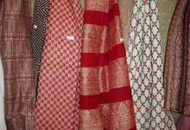 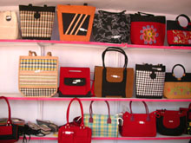

Fashion Accessories

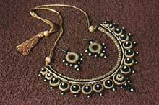 

Technical textiles

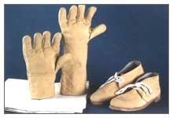 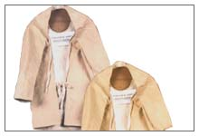

Floor coverings

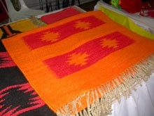 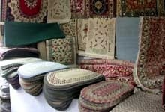

Jute handicrafts

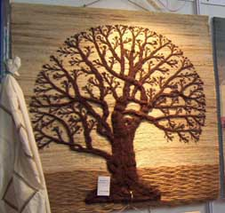 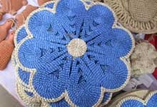 

Jute Footwear Jute Apparel

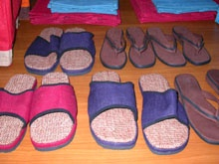 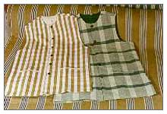

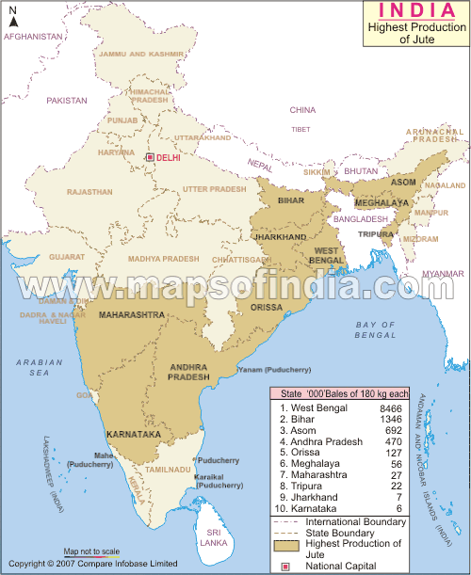

**Strength:**

Jute is a labour intensive industry, which engages 4.35 million people

Jute industry has lot of potential of providing employment especially in East Indian region. The industry offers employment opportunity to 7,500 persons per year.

Jute is an eco-friendly and biodegradable product. With the pressure from green movement, it is going to sustain through consumer's preference.

**Weakness:**

Frequent revision of JMA guidelines (to add or dilute items for jute packing) leaves the industry in confusion whether to invest further on the Jute technology development/product development/market expansion or wait for new policies etc.

Multi unionism is one of the major problems faced by jute industry and engages major concentration of routine management in resolving labour dispute.

Another weakness of jute industry is poor Research & Development (R&D) initiation, invention/reverse engineering effort has been grossly neglected in this sector. .

Marketing has been another weak point of jute industry. It has been maintaining a very slow pace in coming out of traditional way of marketing. Time has come for the industry to think how to market this versatile, eco-friendly and natural fiber.

Indian jute has not been able to build brand image for jute that goes with the quality.

**Opportunity:**

In many areas Indian Jute industry is ahead of other jute producing and manufacturing countries

It has learned how to upgrade a lower grade fiber in the batch mix.

It also leads in diversified value added products.

.**Threats:**

The Department of Food and Public Distribution which is issued orders for packaging paddy and coarse grains in used gunny bags which is a violation of Jute Packaging Material Act, 1987, which is considered as threat by jute industry.

|  |  |  |
| --- | --- | --- |
|  | | |
| 1.  Average land area under jute cultivation | : | 8, 36,000 ha |
| 2.  Average Yield | : | 1.95 ton/ha |
| 3.   a) Average production of Jute | : | 1.63m ton (90 lakh bales) |
| b) Carry over (opening stock) | : | 0.38 m ton (21 lakh bales) |
|  |  |  |
| 4.  Number of farm families | : | 4- 4.5 million |
| 5.  Average internal consumption of jute | : | 1.8 m ton (103 lakh bales) |
| 6.  Number of Jute Mills | : | 78 |
| 7. Number of workers employed in Jute Mills (Approx) | : | 3, 70,000 |
| 8. Average production of jute goods | : | 1,705,000 MT |
| a) Sacking | : | 1,107,000 MT |
| b) Hessian | : | 324,000 MT |
| c) CBC | : | 5,000 MT |
| d) Others | : | 268,000 MT |
|  |  |  |
| 9. Average internal consumption of jute goods | : | 1, 489,000 MT |
| 10. Average export of jute goods | : | 2, 02,000 MT |
| 11. Average export value of jute goods | : | US$ 246 million |
| 12. Average export earnings from JDP | : | US$ 65.9 million |
|  |  |  |

**WORLD PRODUCTION OF JUTE**

|  |  |
| --- | --- |
| **Country** | **Production (**[**Tonnes**](http://en.wikipedia.org/wiki/Tonne)**)** |
| http://upload.wikimedia.org/wikipedia/en/thumb/4/41/Flag_of_India.svg/22px-Flag_of_India.svg.png  [India](http://en.wikipedia.org/wiki/India) | 17,43,000 |
| [http://upload.wikimedia.org/wikipedia/commons/thumb/f/f9/Flag_of_Bangladesh.svg/22px-Flag_of_Bangladesh.svg.png bangladesh](http://en.wikipedia.org/wiki/Bangladesh) | 12,00,600 |
| http://upload.wikimedia.org/wikipedia/commons/thumb/f/fa/Flag_of_the_People%27s_Republic_of_China.svg/22px-Flag_of_the_People%27s_Republic_of_China.svg.png  [People's Republic of China](http://en.wikipedia.org/wiki/China) | 40,000 |
| http://upload.wikimedia.org/wikipedia/commons/thumb/8/8c/Flag_of_Myanmar.svg/22px-Flag_of_Myanmar.svg.png  [Myanmar](http://en.wikipedia.org/wiki/Myanmar) | 30,000 |
| http://upload.wikimedia.org/wikipedia/commons/thumb/8/84/Flag_of_Uzbekistan.svg/22px-Flag_of_Uzbekistan.svg.png  [Uzbekistan](http://en.wikipedia.org/wiki/Uzbekistan) | 20,000 |
| http://upload.wikimedia.org/wikipedia/commons/thumb/9/9b/Flag_of_Nepal.svg/15px-Flag_of_Nepal.svg.png  [Nepal](http://en.wikipedia.org/wiki/Nepal) | 16,988 |
| http://upload.wikimedia.org/wikipedia/commons/thumb/2/21/Flag_of_Vietnam.svg/22px-Flag_of_Vietnam.svg.png  [Vietnam](http://en.wikipedia.org/wiki/Vietnam) | 8,800 |
| http://upload.wikimedia.org/wikipedia/commons/thumb/a/a9/Flag_of_Thailand.svg/22px-Flag_of_Thailand.svg.png  [Thailand](http://en.wikipedia.org/wiki/Thailand) | 5,000 |
| http://upload.wikimedia.org/wikipedia/commons/thumb/0/01/Flag_of_Sudan.svg/22px-Flag_of_Sudan.svg.png  [Sudan](http://en.wikipedia.org/wiki/Sudan) | 3,300 |
| http://upload.wikimedia.org/wikipedia/commons/thumb/f/fe/Flag_of_Egypt.svg/22px-Flag_of_Egypt.svg.png  [Egypt](http://en.wikipedia.org/wiki/Egypt) | 2,200 |
| **World** | 2833041 |



|  |  |  |  |  |
| --- | --- | --- | --- | --- |
|  | | | |  |
|  |  | | | |
|  | | |
|  | |  | |  |

**PRODUCTION**





The statistics of world production of Jute, Kenaf and Allied fibres for the last 10 years shows that it tends to be around 3 million MT a year with the lowest of 2405.95 thousand MT in 2004-05 and highest 3144.91 thousand MT in 2001-02 (Table-3). Global production and production in major producing countries . The recent production volume in Bangladesh and India shows that the production is increasing indicating a sign of encouragement to meet the stimulated demand in the world market s.

The fluctuations in the raw jute production in India can be attributed to decreased acreage under jute cultivation on account of strikes in the jute mills and partly due to low productivity and early floods. In China the yield per hectare is going down resulting in lower production because the Chinese growers now tend to grow fibre crops in poorer soil and prefer to grow cereals in better soil. Apart from climatic and market factors, non-availability of quality seed at the right time also has adverse effect on fibre production. However, since 2009 the market price of raw jute in the previous season is playing key role in jute production. Production in Bangladesh has gone up to 1080 thousand MT in 2009-10, the highest in the last decade and an increase of 16% from the previous year. The production in India has increased by about 10% in 2009-10 compared to 2008-09. World production has also increased in 2009-10 by about 12% from the previous year (2008-09).

|  |  |  |  |  |  |  |  |  |  |  |
| --- | --- | --- | --- | --- | --- | --- | --- | --- | --- | --- |
| **Total Jute Allied Fibers & Kenaf** | | **2001-02** | **2002-03** | **2003-04** | **2004-05** | **2005-06** | **2006-07** | **2007-08** | **2008-09** | **2009-10** |
| **World** |  | **3144.91** | **3084.93** | **2852.33** | **2405.95** | **2724.13** | **3021.1** | **2997.32** | **2596.6** | **2883.9** |
| Bangladesh | | 924.7 | 793.3 | 963 | 810 | 965 | 990 | 990 | 931 | **1080** |
| China |  | 136.0 | 130.0 | 99.78 | 86.92 | 82.82 | 86.8 | 86.8 | 80.0 | **80.0** |
| India |  | 1890 | 1980 | 1620 | 1350 | 1530 | 1800 | 1782 | 1476 | **1620** |
| Nepal |  | 16.4 | 17 | 17.04 | 16.89 | 17.66 | 17.1 | 16.8 | 2.9 | **1.8** |
| Thailand |  | 56 | 46.37 | 41.33 | 35.66 | 4.6 | 3.6 | 2.2 | 2.9 | **1.8** |

** WORLD EXPORT OF JUTE PRODUCTS**

Export of jute products by India shows an increasing trend as it exported 177.8 thousand MT in 2000 and 207.6 thousand MT an increase of 16.8% .Export by Europe and Thailand has a declining trend while export by Nepal and China shows an increasing trend.

With the growing awareness about pollution free environment natural fibers products made of jute is having a huge potential market. IJSG feels that it is high time to launch a generic promotion of jute and allied natural fibers by way of holding international seminars, exhibitions, buyer-seller meets and even jute specific international exhibitions along with simultaneously increasing production capacities, establish reliable supply mechanism to cash on the global eco-enthusiasm.

|  |  |  |  |  |  |  |  |  |  |  |
| --- | --- | --- | --- | --- | --- | --- | --- | --- | --- | --- |
|  | 2000 | 2001 | 2002 | 2003 | 2004 | 2005 | 2006 | 2007 | 2008 | 2009 (provisional) |
| **World** | **643.8** | **649.9** | **680.3** | **729.5** | **748.1** | **800.3** | **774.1** | **832.7** | **773.0** | **768.0** |
| Bangladesh | 378.0 | 409.2 | 400.6 | 391.9 | 439.4 | 476.0 | 478.9 | 549.7 | 480.0 | 560.0 |
| China | 6.5 | 11.2 | 11.1 | 15.9 | 16.1 | 7.6 | 18.5 | 21.1 | 12.6 | 16.8 |
| India | 177.8 | 151 | 189.9 | 243.8 | 193.0 | 208.1 | 189.5 | 175.6 | 207.6 | 135. |
| Nepal | 10.0 | 10.0 | 10.0 | 10.0 | 13.0 | 13.0 | 13.0 | 13.0 | 13.0 | 17.4 |
| Thailand | 7.2 | 8.3 | 7.3 | 7.9 | 6.3 | 6.3 | 3.4 | 2.8 | 1.5 | 0.9 |

**EXPORTS**

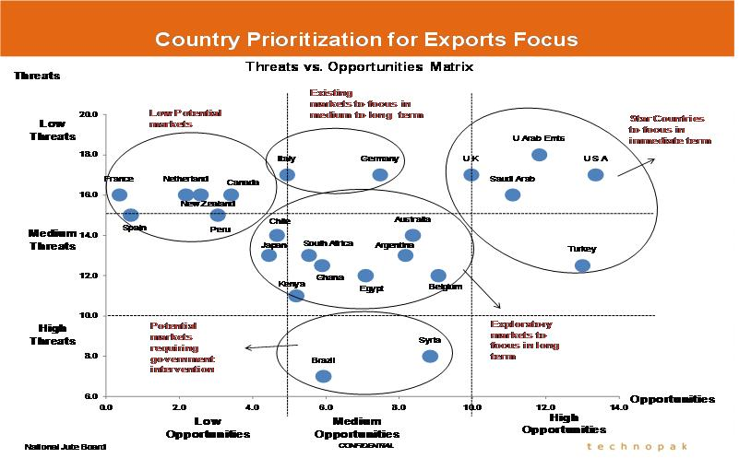

# http://www.jute.com:8080/image/image_gallery?uuid=a0450b56-afe6-4979-a7fc-34382ba64a41&groupId=22165&t=1337151489238

# ****Major Issues of Buyers That Need To Be Addressed****

* High & unstable prices
* Lack of marketing efforts / Lack of information about Indian suppliers / jute products
* Poor service levels / Lack of relationship building by suppliers
* Unsatisfactory or inconsistent quality
* Limited designs & product variety
* Technical limitations of jute usage
* Supply chain is not streamlined resulting in high lead times and inefficiencies
* High duty and taxes / Tariff and non tariff barriers in specific markets
* Inaccessibility to jute related data (e.g. prices etc.)

**NJB has already undertaken steps to address the following recommendations:**

* Product standardization
* Organize Stake holder Education Program
* Open Marketing / liaison offices in key locations
* Open warehouse for JDPs at select markets
* Develop Online information portal
* Developing brand India for Jute products
* Promotional activities like organizing road shows, workshops, trade fair participation et

# 

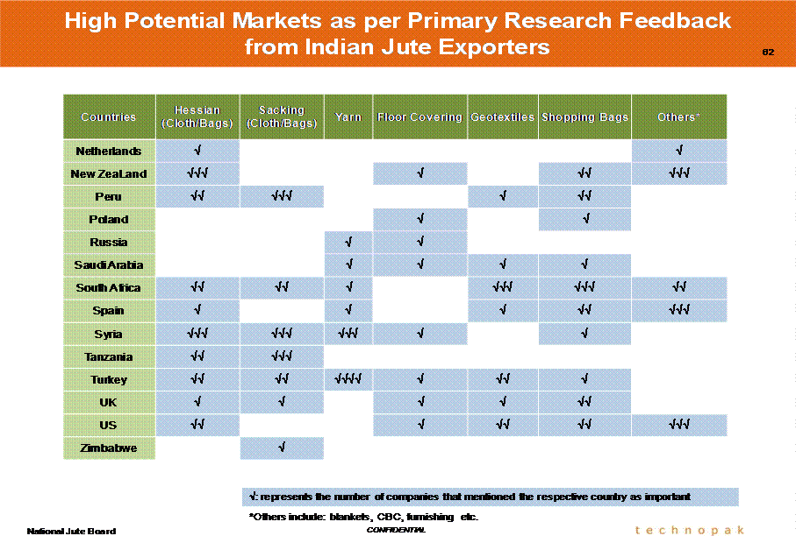

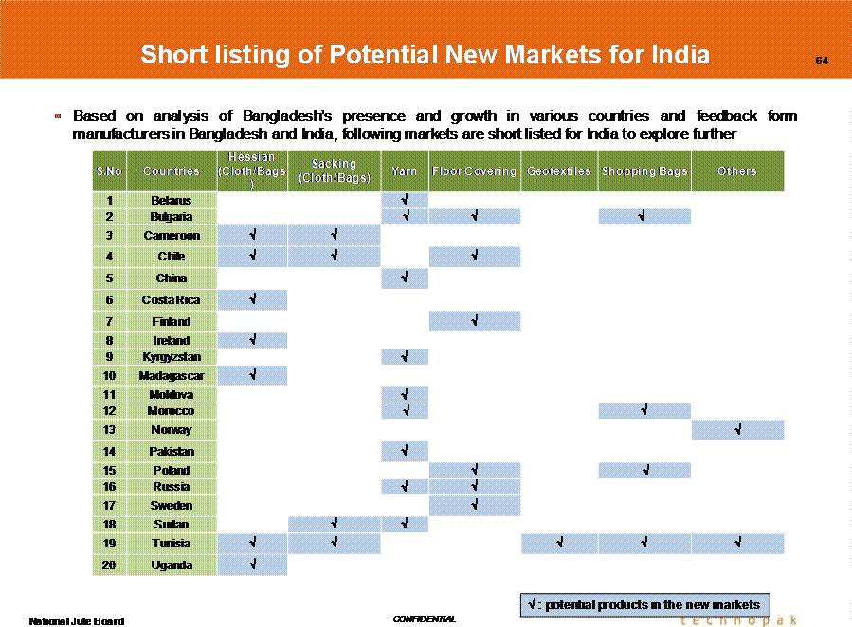

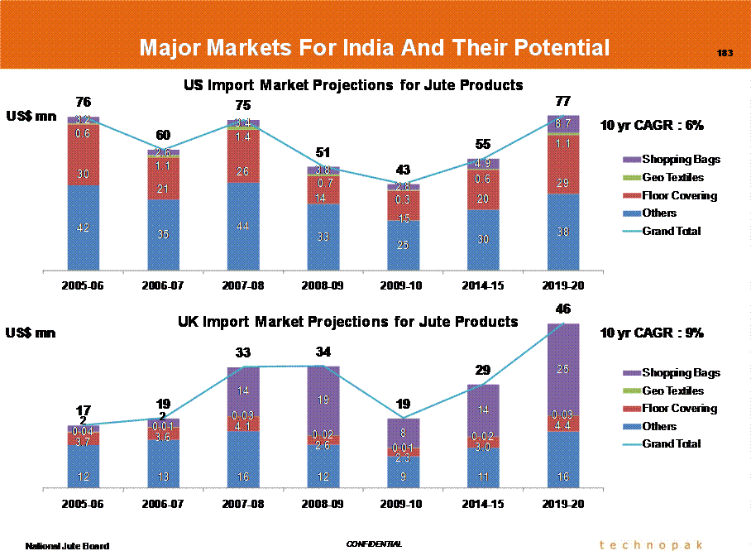

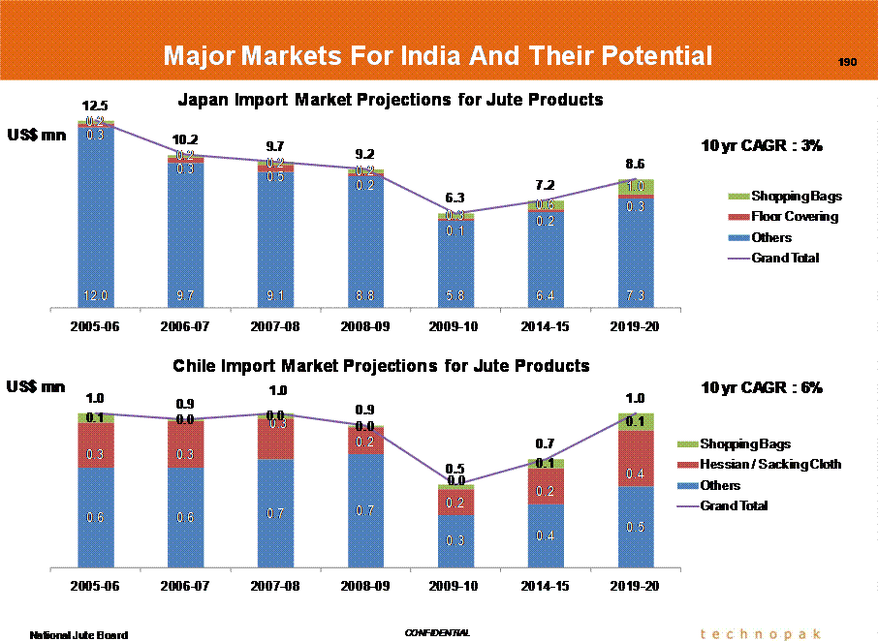

**CHAPTER 3**

**Statistical Data Analysis and Discussion of Results**

**EXPORT PRICE OF JUTE IN INDIA**

|  |  |  |  |  |
| --- | --- | --- | --- | --- |
| **Year** | **Hessian(40"10oz)** | | **Sacking (B-Twills)** | |
| **per100Metres** | | **per 100 Bags** | |
| **Rupees** | **US$** | **Rupees** | **US$** |
| 2010-2011 | 1795 | 39.4 | 3308 | 72.6 |
| 2009-2010 | 1546 | 33.3 | 2914 | 62.7 |
| 2008-2009 | 1182 | 24.8 | 3189 | 66.8 |
| 2007-2008 | 1026 | 25.4 | 2757.4 | 68.3 |
| 2006-2007 | 1077 | 24.4 | 3085 | 69.8 |
| 2005-2006 | 1033 | 23.1 | 3011 | 67.3 |
| 2004-2005 | 959 | 21.5 | 2599 | 58.4 |
| 2003-2004 | 872 | 19.1 | 2277 | 49.8 |  |
| 2002-2003 | 913 | 19 | 2285 | 47.7 |
| 2001-2002 | 1091 | 22.6 | 2647 | 54.9 |  | |

**PRODUCTION IN INDIA**

|  |  |  |
| --- | --- | --- |
| YEAR | HESSIAN | SACKING |
| 2001-2002 | 325.7 | 981 |
| 2002-2003 | 279.6 | 1024.5 |
| 2003-2004 | 349.4 | 1012 |
| 2004-2005 | 294.7 | 955.3 |
| 2005-2006 | 312.7 | 974.8 |
| 2006-2007 | 316.9 | 1019.2 |
| 2007-2008 | 362.3 | 936.1 |
| 2008-2009 | 340.3 | 1117.5 |
| 2009-2010 | 280.9 | 1066.7 |
| 2010-2011 | 218.7 | 930.6 |

**CORRELATION ANALYSIS**

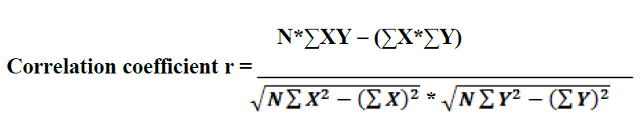

HESSIAN

| **Descriptive Statistics** | | | |
| --- | --- | --- | --- |
|  | Mean | Std. Deviation | N |
| Hessian production | 308120.00 | 41915.969 | 10 |
| Hessian exports | 23.400 | 4.1355 | 10 |

| **Correlations** | | | |
| --- | --- | --- | --- |
|  | | Hessian production | Hessian exports |
| Hessian production | Pearson Correlation | 1 | -.617 |
| Sig. (2-tailed) |  | .057 |
| N | 10 | 10 |
| Hessian exports | Pearson Correlation | -.617 | 1 |
| Sig. (2-tailed) | .057 |  |
| N | 10 | 10 |

the correlation between production and exports is - 0.617 which is negative correlation

**Regression**

model summary

| Model | R | R Square | Adjusted R Square | Std. Error of the Estimate |
| --- | --- | --- | --- | --- |
|
| 1 | .557a | .311 | .224 | 7.3225 |

**Anova**

| Model | | | | Sum of Squares | | df | | Mean Square | | F | | Sig. | |
| --- | --- | --- | --- | --- | --- | --- | --- | --- | --- | --- | --- | --- | --- |
| 1 | | Regression | | 58.645 | | 1 | | 58.645 | | 4.924 | | .057a | |
| Residual | | 95.275 | | 8 | | 11.909 | |  | |  | |
| Total | | 153.920 | | 9 | |  | |  | |  | |
| a. Predictors: (Constant), Hessian production  b. Dependent Variable: Hessian exports  **Coefficientsa** | | | | | | | | | | | | | |
| Model | | | | Unstandardized Coefficients | | | | Standardized Coefficients | | t | | Sig. | |
| B | | Std. Error | | Beta | |
| 1 | | (Constant) | | 42.164 | | 8.526 | |  | | 4.945 | | .001 | |
| Hessian production | | -6.090 | | .000 | | -.617 | | -2.219 | | .057 | |
|  | | | | | | | | | | | | | |
|  | | | | | | | | | | | | | | |

|  | Mean | Std. Deviation | N |
| --- | --- | --- | --- |
| sacking production | 910690.00 | 290439.592 | 10 |
| sacking exports | 59.750 | 8.3151 | 10 |

| **Correlations** | | | |
| --- | --- | --- | --- |
|  | | sacking production | sacking exports |
| sacking production | Pearson Correlation | 1 | .557 |
| Sig. (2-tailed) |  | .094 |
| N | 10 | 10 |
| sacking exports | Pearson Correlation | .557 | 1 |
| Sig. (2-tailed) | .094 |  |
| N | 10 | 10 |

**Regression**

| **Correlations** | | | |
| --- | --- | --- | --- |
|  | | sacking exports | sacking production |
| Pearson Correlation | sacking exports | 1.000 | .557 |
| sacking production | .557 | 1.000 |
| Sig. (1-tailed) | sacking exports | . | .047 |
| sacking production | .047 | . |
| N | sacking exports | 10 | 10 |
| sacking production | 10 | 10 |

**Model summary**

| Model | R | R Square | Adjusted R Square | Std. Error of the Estimate |
| --- | --- | --- | --- | --- |
|
| 1 | .557a | .311 | .224 | 7.3225 |

| Model | | | | Sum of Squares | | df | | Mean Square | | F | | Sig. | |
| --- | --- | --- | --- | --- | --- | --- | --- | --- | --- | --- | --- | --- | --- |
| 1 | | Regression | | 193.309 | | 1 | | 193.309 | | 3.605 | | .094a | |
| Residual | | 428.956 | | 8 | | 53.619 | |  | |  | |
| Total | | 622.265 | | 9 | |  | |  | |  | |
| a. Predictors: (Constant), sacking production  b. Dependent Variable: sacking exports | | | | | | | | | | | | | |
| **Coefficientsa** | | | | | | | | | | | | | |
| Model | | | | Unstandardized Coefficients | | | | Standardized Coefficients | | t | | Sig. | |
| B | | Std. Error | | Beta | |
| 1 | | (Constant) | | 45.218 | | 7.996 | |  | | 5.655 | | .000 | |
| sacking production | | 1.596 | | .000 | | .557 | | 1.899 | | .094 | |
| a. Dependent Variable: sacking exports | | | | | | | | | | | | | |

Exports = 45.218 +1.596* PRODUCTION

**Chapter -4 (CONCLUSION)**

Importance of natural fibres like jute/ kenaf in the lives of the people of the producing countries is provide pollution free environment to everyone For the growth of global jute economy growers and entrepreneurs face a number of challenges .

The most important issues discussed in the previous chapters as follows.

**Challenges for jute cultivation**: Farmers face a number of challenges like availability of good quality seed as well as the problem of scarcity of sufficient water.

**Raw Jute**: Raw jute production needs to be increased to meet the enhanced present and future demand in the domestic as well as the export market. The need for large scale production of jute shopping bags meet even a small fraction of potential global demand, the increasing use of jute geo-textiles.

**Seed scenario**: short supply of jute seeds can be addressed in a better way by having a regional approach to the issue in India. Private entrepreneurs of India should be encouraged to commercially produce seeds under strict quality control in India .

**Modernisation of Jute Mills**: Jute mills in India need to be modernised to reduce the conversion cost, maintain product quality, make jute products price competitive and for ensuring compliances with environmental protocols. It is a long term investment and there is no shortcut to future growth.

**Diversification of jute**: A host of diversified jute products have been developed which need to be produced in large scale and marketed in domestic as well as foreign market. India need to diversify from traditional to new sectors. This is logical step to greater value addition beneficial to both the industry and the country as a whole.

**Jute Bags**: Successful replacement of polythene bags can be ensured only if alternative jute bags are readily available in required numbers and at reasonable price. Jute mills should take initiative in efforts .

**BIBILIOGRAPHY**

<http://www.worldjute.com/>

<http://www.jute-industry.com/jute-industry-india/jute-trade-associations.html>

<http://www.jute.org/statistics_search.php>

<http://www.juteproductsindia.com/>

<http://en.wikipedia.org/wiki/Jute>

<http://jutecomm.gov.in/Prod_htm.htm>